Displaying all facts on the index page
In the previous step, we rendered a couple of string values in our template. It was a good demonstration of how static content can be displayed in a template. In the following section, we will build on this knowledge to be able to render dynamic content.
Let’s update the ListFacts handler so that it sends facts from the database to our frontend template. As mentioned previously, we can send any type of Go data to our templates. The facts variable holds a slice of Fact, the underlying type of a Fact is struct.
1  2  3  4  5  6  7  8  9  10  11  12  13  14  15  16  17  18  19  20  21  22  23  24  25  26  27  28  29  30  31 | package handlers  import (  "github.com/divrhino/divrhino-trivia/database"  "github.com/divrhino/divrhino-trivia/models"  "github.com/gofiber/fiber/v2"  )  func ListFacts(c *fiber.Ctx) error {  facts := []models.Fact{}  database.DB.Db.Find(&facts)  return c.Render("index", fiber.Map{  "Title": "Div Rhino Trivia Time",  "Subtitle": "Facts for funtimes with friends!",  "Facts": facts, // send the facts to the view  })  }  func CreateFact(c *fiber.Ctx) error {  fact := new(models.Fact)  if err := c.BodyParser(fact); err != nil {  return c.Status(fiber.StatusInternalServerError).JSON(fiber.Map{  "message": err.Error(),  })  }  database.DB.Db.Create(&fact)  return c.Status(200).JSON(fact)  }
Inside the index.html view, we can range over the Facts and display each of them as follows.
1  2  3  4  5  6  7  8 | <div>  {{ range .Facts }}  <div>  <p>{{ .Question }}</p>  <p>{{ .Answer }}</p>  </div>  {{ end }}  </div>
We should also handle scenarios where no Facts are present. We can use if / else blocks to do some conditional rendering. If there are Facts present, we will range over and render each one. If there are no Facts, we will display a message that says there are no facts with a link to /fact where we can create new facts.
1  2  3  4  5  6  7  8  9  10  11  12  13  14  15 | <div>  {{ if .Facts }}  {{ range .Facts }}  <div>  <p>{{ .Question }}</p>  <p>{{ .Answer }}</p>  </div>  {{ end }}  {{ else }}  <div>  <p>No facts yet.</p>  <p><a href="/fact">Add new</a></p>  </div>  {{ end }}  </div>
We’ve cleared the database, so there are currently no Facts present. Our index view currently looks like this in the browser:
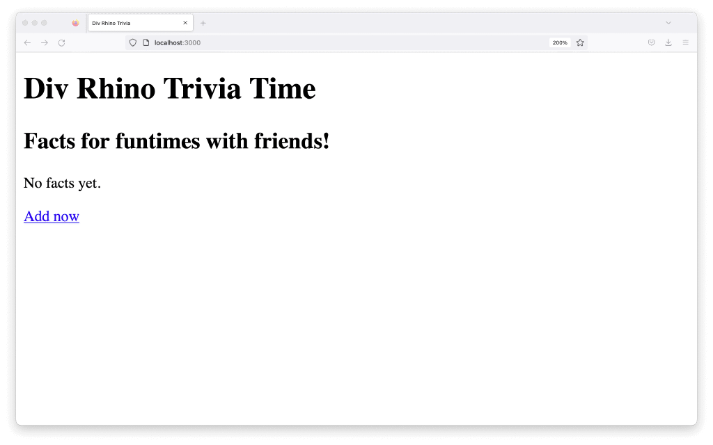
The Add new link goes to a page that does not exist yet, so we will create it in the next section.

